Administrator guide
jWebSocket
C# Client Library
Version 1.0

Version Control
Date | Version | Description | Author
4/3/12 | 1.0 | Creation of the document | Rolando Betancourt Toucet

- Process application download

To achieve the correct operation of this library should download the following files.

Archivo | Tamaño | Descripción
ClientLibrary.dll | 52 KB | Main file that contains all the business logic.
log4net.dll | 292 KB | Is referenced by ClientLibrary.dll.
JSON.dll | 16 KB | Is referenced by ClientLibrary.dll.
Config.xml | 2 KB | Configuration file.
CSharpClientLibrary.rar | 121 KB | Contains all files.

The URL where it is available for download is: https://jwsdev.org:9443/svn/jWebSocket/branches/jWebSocket-1.0/jWebSocketCSClient
- Characteristics of the installation environment
You need to have an environment running Windows XP or any later version. Must have an installation of the Integrated Development Environment (IDE) Visual Studio 2005 or a later version and. NET Framework 4.0

- Installation process
- Create a form application or console application using the Visual Studio IDE.
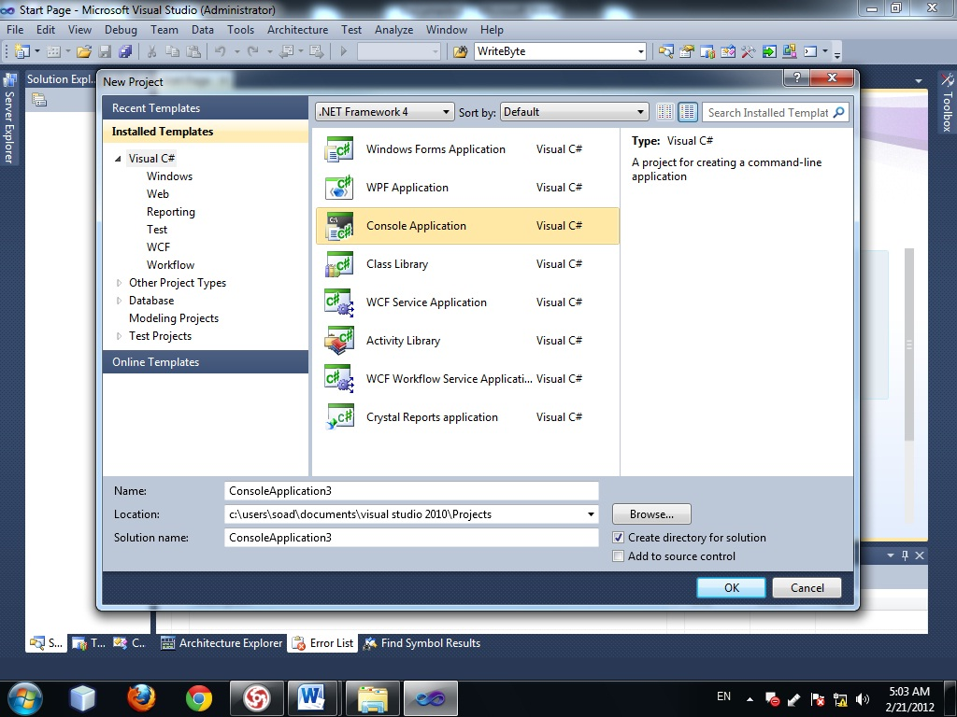

Picture 1: Create application

- Select the Framework 4.0 which is recommended to develop the application.
- Right-click the recently created project, where the menu will to mark the latter option “properties”.
- In the option Target Frameworks we choose .NET Framework 4.0.
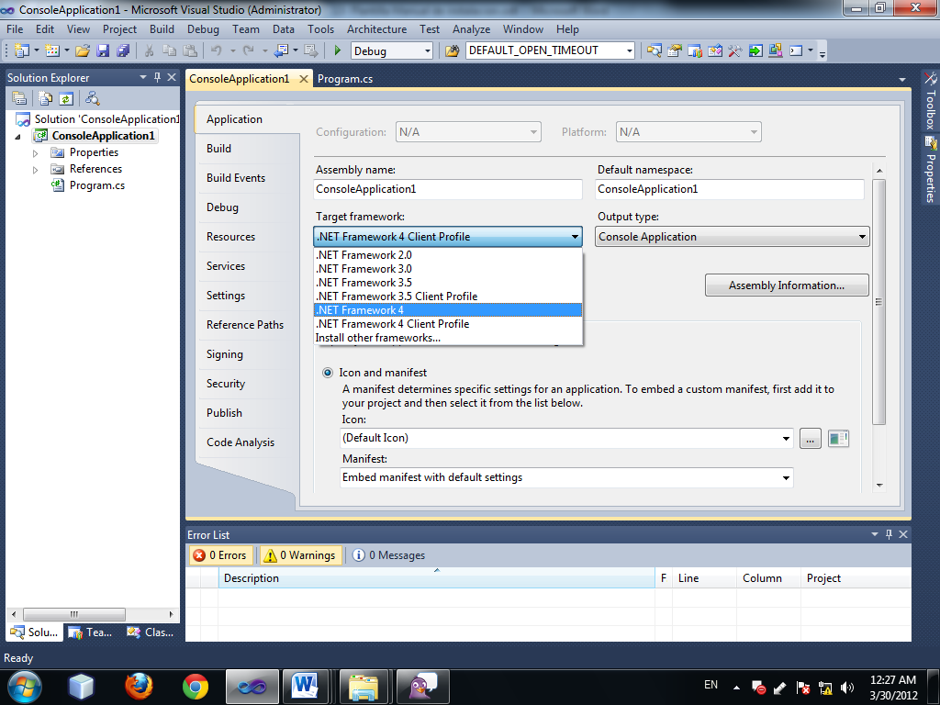

Picture 2: Select Framework

- Must copy the installation files in the root directory of your application to add reference.
- Right click on References and choose the option Add References.
- In the new window choose the tab Browse
- Look root directory and select the files you're going to reference
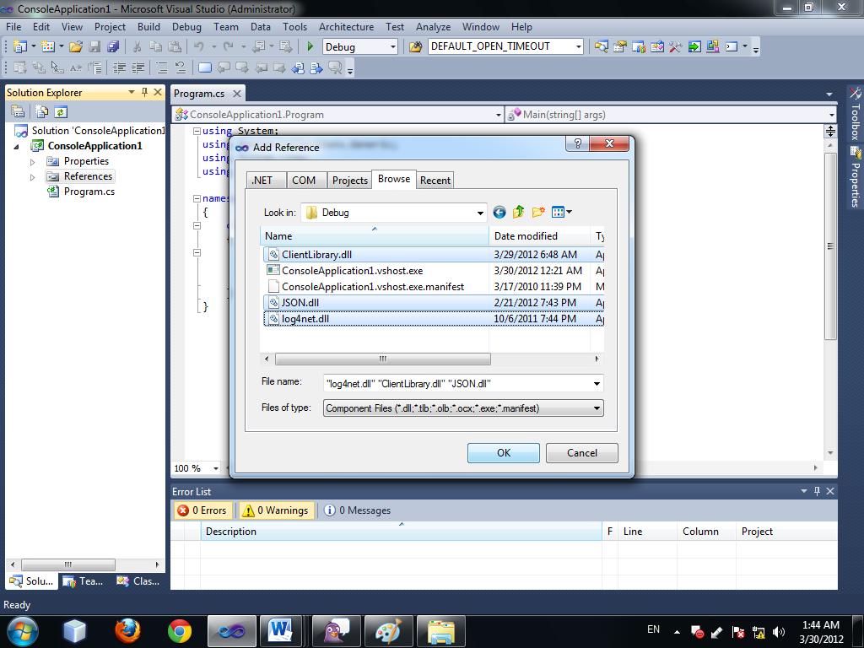
Picture 3: Add reference

- Add the namespace from 3 libraries in class where Let us go to use.
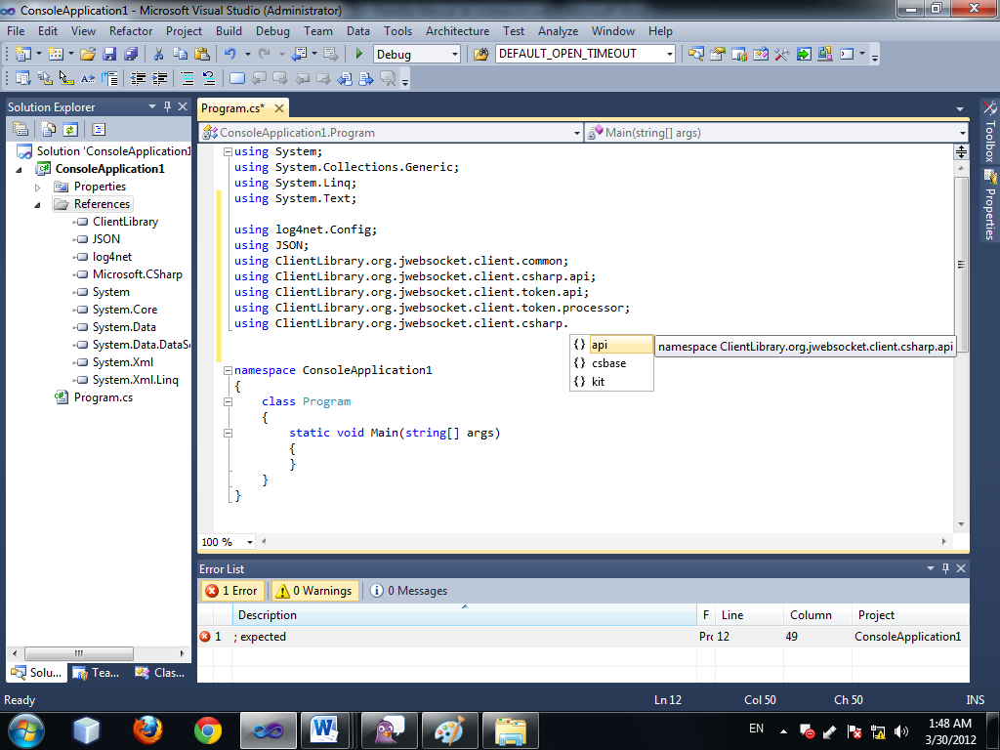
Picture 1: Add namespace

3.1 Hardware implementation (optional)
No need to specify hardware features.
4. Configuration Options
Using the Config.xml file you can change some parameters of the operation of the application.
5. Initial operation
No need for post-installation configurations.
5. Application Management
No need to manage the application.

